**Name : Bassmala Youssef ismail ahmed**

**Group :** **2**

**Section:** **11**

**b.n:13**

**Topic : programming languages**

**Brief about programming languages :**

A **programming language** is a [formal language](https://en.wikipedia.org/wiki/Formal_language) comprising a set of [strings](https://en.wikipedia.org/wiki/Formal_language#Words_over_an_alphabet) that produce various kinds of [machine code output](https://en.wikipedia.org/wiki/Machine_code).

Programming languages are one kind of [computer language](https://en.wikipedia.org/wiki/Computer_language), and are used in [computer programming](https://en.wikipedia.org/wiki/Computer_programming) to implement [algorithms](https://en.wikipedia.org/wiki/Algorithm).

Most programming languages consist of [instructions](https://en.wikipedia.org/wiki/Machine_instruction) for [computers](https://en.wikipedia.org/wiki/Computer).

There are programmable machines that use a set of [specific instructions](https://en.wikipedia.org/wiki/Domain-specific_language), rather than [general programming languages](https://en.wikipedia.org/wiki/General-purpose_language). Since the early 1800s, programs have been used to direct the behavior of machines such as [Jacquard looms](https://en.wikipedia.org/wiki/Jacquard_loom), [music boxes](https://en.wikipedia.org/wiki/Music_box) and [player pianos](https://en.wikipedia.org/wiki/Player_piano).

The programs for these machines (such as a player piano's scrolls) did not produce different behavior in response to different inputs or conditions.

**Screenshots :**

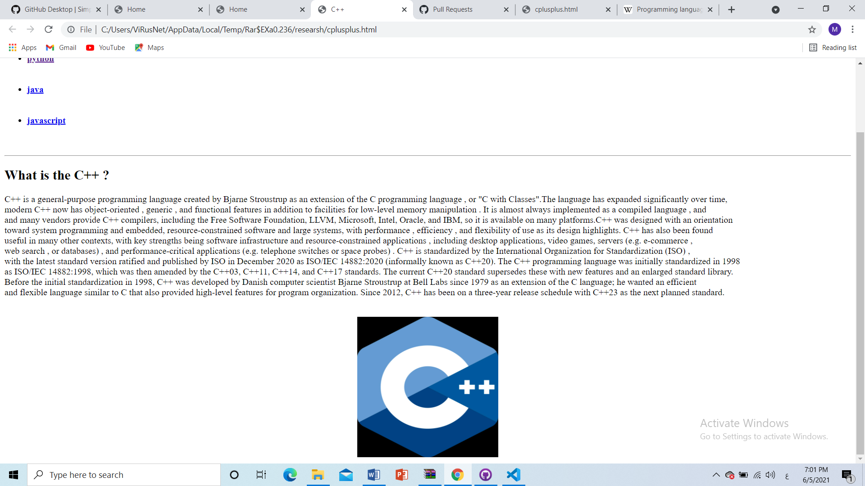

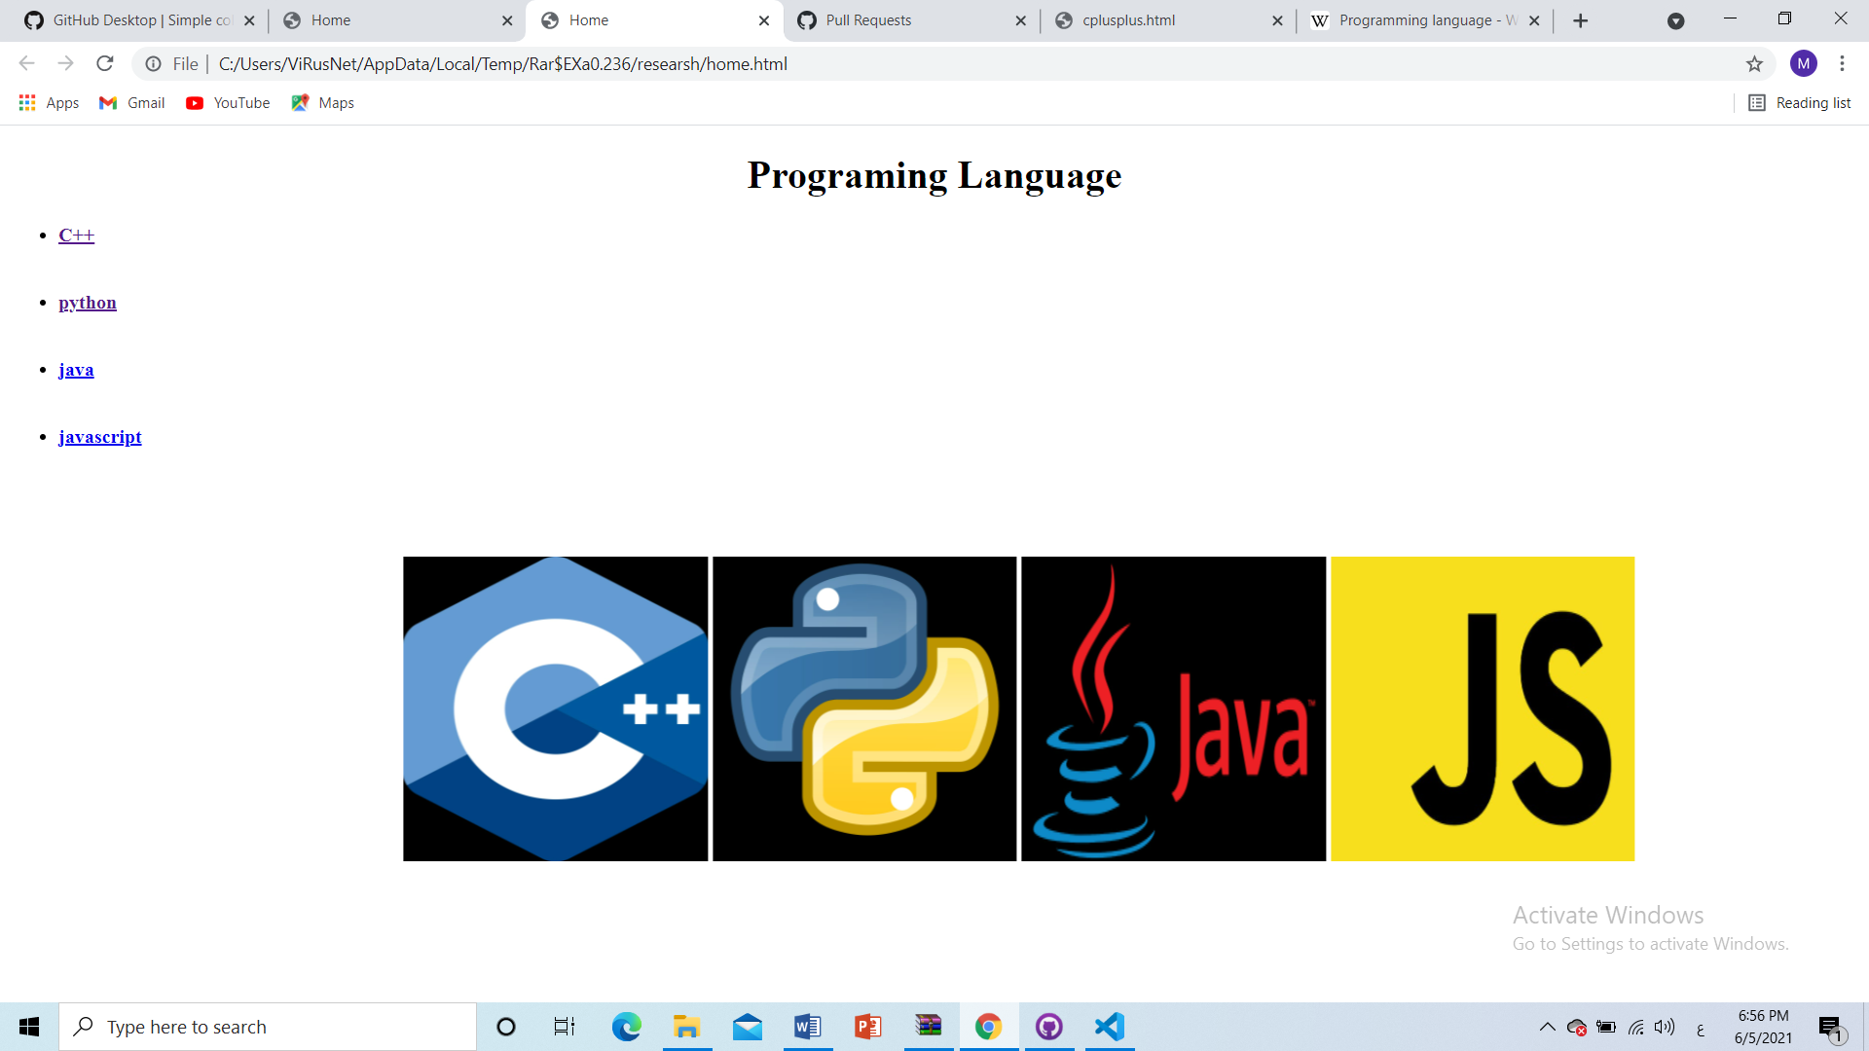



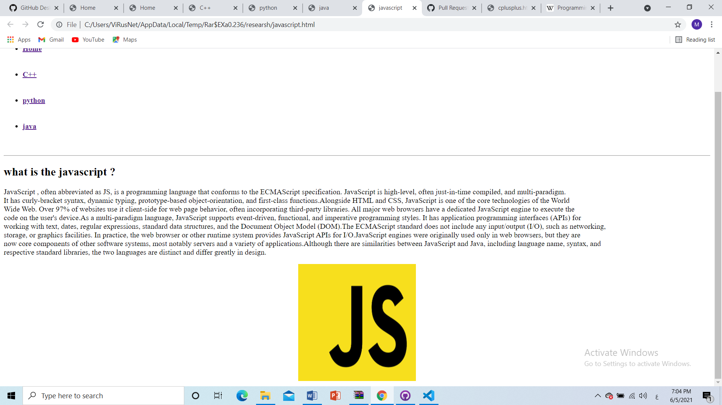

**Part of source code :**

